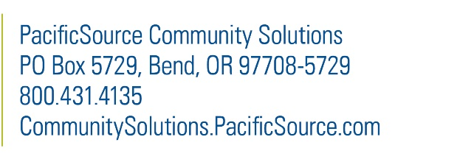
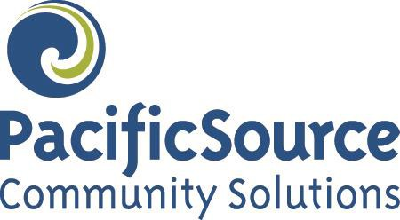

Permission to Use and Share Protected Health Information
Usted puede recibir este documento en otro idioma, impreso en una letra más grande o de otra manera que sea mejor para usted. También puede solicitar un intérprete. Esta ayuda es sin costo. Llame al (800) 431-4135 o por TTY al 711. Aceptamos llamadas del servicio de retransmisión.

You can get this document in another language, large print, or another way that’s best for you. You can also request an interpreter. This help is free. Call (800) 431-4135 or TTY 711. We accept all relay calls.

I give PacificSource Community Solutions permission to share the personal health information below with the persons or groups on this form.

All sections must be complete for this form to be good.
Please print your responses on the form.

Member Information
Member Name: |  |  |  | Date of Birth:
Member Address:
City: |  | State: |  |  | Zip:
Phone: | Member ID Number:
Who Can Receive my Personal Health Information
Name:
Address:
Phone: |  |  | Fax:
This person is allowed to change my primary care provider: |  |  |  |  | Yes | No

Types of Information to be Released and How it Will be Used
If the information has any of the types of records or information listed below, additional laws may protect it. I understand that this information will only be released if I put my initials in the space next to the information:
 | HIV/AIDS Information |  | Mental Health Information
(Initials) |  | (Initials)
 | Genetic Testing Information |  | Drug/Alcohol Diagnosis, Treatment, and Referral
(Initials) |  | (Initials)
I understand that the information used and released as stated in this form may be shared again, and no longer protected under federal or state law. I also understand that federal or state law does not allow sharing of HIV/AIDS, mental health and drug/alcohol diagnosis, treatment, vocational rehabilitation records, or referral information without my special permission.
My personal health information will be used for the purpose below. PacificSource will only give the necessary information.
Please also list any limits you want on the use of this information:

Right to Cancel Release
I understand I have the right to cancel this permission in writing at any time. If I cancel it, the information described above will no longer be used or released for the reasons here. Any uses or releases made with my permission cannot be taken back.
To cancel this release, I understand I must send a written and signed statement. Please mail to PacificSource Community Solutions, PO Box 5729 Bend, OR 97708-5729. You may also fax your request to (541) 322-6423.
Unless I cancel this release, it will remain in effect for twenty-four (24) months (2 years) from the date of my signature below, or earlier if requested.

Acknowledgement and Signature
By signing this form, I permit PacificSource Community Solutions and its partners to release the following specific private information about me. I have read this release and understand that the day I sign and date this form is when it becomes effective.
Signature: | Date:

Signature of Authorized Representative
Relationship to the Member:
Signature: | Date:
Please provide all legal documentation proving your relationship to the member. (Upon request only)

Children of the following ages must sign the “Permission to Use and Share Protected Health Information” form to release their personal health information to any person or entity:

14 years of age and above – Chemical Dependency and Mental Health
- 15 years of age and above – All other medical conditions

Please keep a copy of this form for your records.

By using this document, you agree to the following conditions: This form is provided as a service only. You may not change this form in any manner. The most recent version of this form replaces all prior versions.
Please submit completed form to us via the following:
Email: CommunitySolutionsCS@PacificSource.com
Mail: PacificSource Community Solutions
P.O. Box 5729 Bend, OR 97708-5729
Fax: (541) 322-6423

